Issue Report
Forum: UN General Assembly
Issue 2: The question of addressing global migration crises with focus on the
Mediterranean and U.S.–Latin America migration routes
Chairs: Madeleine Cabana & Hana Raskin

The question of addressing global migration crises with focus on the Mediterranean and U.S.–Latin America migration routes
Videos
- IOM at 70 - The Voices of Migrants
- A Crisis Unfolding:Migration and Refugees in Latin America | 2022 Concordia Americas Summit
- Europe's Migration Tragedy: Life and death in the Mediterranean
- Europe’s Migrant Crisis Explained
- Migrant Crisis: The Deadly Journey from El - Salvador to the USA | The Dreamers | ENDEVR Documentary
- What's Causing the Central American Migration Crisis? | History
Articles
- Global Overview of Migration Routes 2025 - IOM UN Migration
- UNHCR- Mediterranean Situation Overview
- IOM - Missing Migrants Project
- IOM- Central Mediterranean Route Report
- UNHCR- Americas Situation
- FRONTEX - Irregular Border Crossing in the EU
- Migration Data Portal - Irregular Migration Explained

Key Terms

Migration: widespread movement of people from one area to another, either within a country or across international borders.

Refugee: A refugee is someone who is unwilling or unable to return to their country owing to a reasonable and provable fear of being persecuted for reasons of race, religion, nationality,
political opinion, or membership in a particular social group. Defined in the 1951 Refugee
Convention.

Asylum Seeker: a person who has fled their home country and formally applied for international protection, but whose request is still under legal evaluation by the host country’s authorities.

Internally Displaced Person (IDP): people who have been forced to flee their home due to
conflict, persecution, violence or disasters, however, remain within the borders of their countries.

Migrant Smuggling: illicit recruitment of migrants into an illegal or irregular arrangement to
cross into a country where they are not a national or a permanent resident in exchange for
financial or other material benefit.

Non-Refoulement: a legal principle that prohibits a country from expelling, deporting or
returning asylum seekers and/or refugees to the territories where their life or freedom would be threatened, or where they risk severe human rights violations.

Overview

Migration, having existed throughout history, has allowed families to reunite, young graduates to seek new opportunities and exposure to diverse cultures. However it has most recently become one of the defining challenges of the 21st century. This is due to the increase of movement as a result of conflict, persecution, poverty, political instability, or environmental disasters. Although this movement can often contribute to economic growth and cultural exchange, the increase in irregular migration has challenged and placed pressure on governments across both humanitarian and political domains.

In Europe, the scale of this challenge became particularly evident during the 2015 Crisis in the Mediterranean. More than 1 million migrants and refugees arrived to Europe via the Mediterranean Sea, which was,in fact, the highest number ever recorded. Among them, 3,771 people died or went missing in an attempt to cross that year, bringing global attention to the European migration policy. There are three main routes that exist in the Mediterranean: Central Mediterranean Route, from Libya/Tunisia to Italy and Malta ; Eastern Mediterranean Route, from Turkey to Greece and Cyprus; and the Western Mediterranean Route, fro Morocco/Algeria to Spain. Indeed, the Central Mediterranean Route is considered one of the most dangerous routes due to its long sea journey, lack of secure means of transportation, and unpredictable weather conditions, and thus explains why over 28,000 people have died or have gone missing since 2014. These statistics have also placed an increased relevance to the rest of the world, instead of just the European continent.

Migration routes in the Americas present a slightly different, but equally urgent, challenge. Over the last decade, particularly after the global pandemic of COVID-19 in 2020, migration has increased dramatically, with 520,085 people crossing the Darién Gap in 2023,

whereas only about half (248,284) did so just a year prior. Moreover, the dense jungle between Colombia and Panama that connects South and Central America consists of no roads, also making it widely considered one of the world’s most dangerous migration routes. There, migrants are faced with dangerous terrain, dehydration, disease, violence and exploitation by criminal groups. Specifically, over 30% of the 1,380 migrants interviewed by the UNHCR reported experiencing abuse there. The Médecins Sans Frontières (MSF) recorded 214 cases of sexual violence in 2023, averaging one report every 3.5 hours.Children are also particularly vulnerable, with about 1 in 4 of the travellers being children in 2024. Most migrants who take this route tend to seek asylum or protection in the United States or Canada, placing increasing pressure on the border and asylum systems of said countries.

There have been some international actions that have attempted to resolve this issue. For example, the 1951 Convention Relating to the Status of Refugees, which was signed to be the cornerstone of international refugee law. It was adopted in the aftermath of World War II, and established who qualified as a refugee and outlined the rights they were entitled to. In addition, it introduced the principle of non-refoulement, prohibiting nations from returning refugees to places where they would face persecution. Originally, it only applied to people displaced by events that had occurred in Europe before the 1st of January 1951, but with the expansion in refugee crises beyond Europe, the 1967 Protocol Relating to the Status of Refugees removed the Convention’s geographical and temporal limitations, making protection universal. More recently and voted for unanimously by the 193 UN Member States, was the 2016 New York Declaration for Refugees and Migrants represented one of the strongest commitments to international solidarity on migration and displacement. It committed states to protect the human rights of all refugees and migrants, combat xenophobia and discrimination, expand access to education for refugee and migrant children, and share responsibility more equitably among states. Two years later, in 2018, the Global Compact for Safe, Orderly, and Regular Migration (GCM) became the first intergovernmentally negotiated agreement, covering all dimensions of international migration, signed by 164 Member States in Marrakech, Morocco, containing 23 main objectives that all revolve around the safety and legality of migration. Nevertheless, the Compact is non-legally binding, and several countries, most notably the United States, chose not to adopt it, arguing that migration policy is a matter of national sovereignty.

Despite decades of international cooperation and legal frameworks, global displacement continues to rise, especially within the Mediterranean and American migration routes. Thus, many destination countries face overburdened asylum systems, resulting in lengthy processing times and backlogs, both of which decrease the level of safety for the migrant. Furthermore, frontline states often struggle to balance humanitarian obligations with domestic political pressures and limited resources. Future solutions regarding migration crises will require finding a balance between border security and national sovereignty with the protection of human rights and international obligation. This issue aligns closely with SDG 10 (Reduced Inequalities) from the United Nations Sustainable Development Goals ,

particularly Target 10.7 on facilitating safe and orderly migrations. As migration patterns continue to evolve, so too must the international response.

Statistics & Infographics

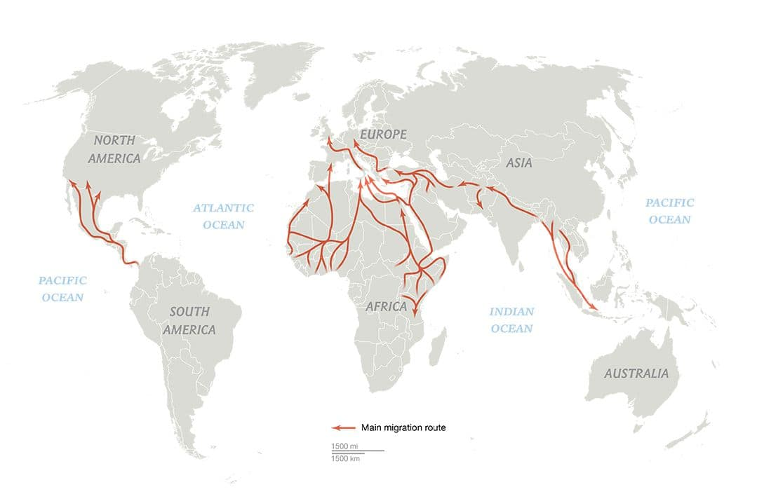
- Migrants & Refugees Infographics - UN
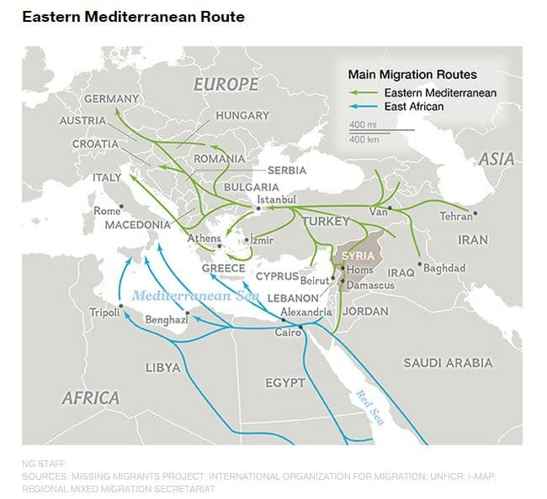

(IOM Migration Blog) Figure 1
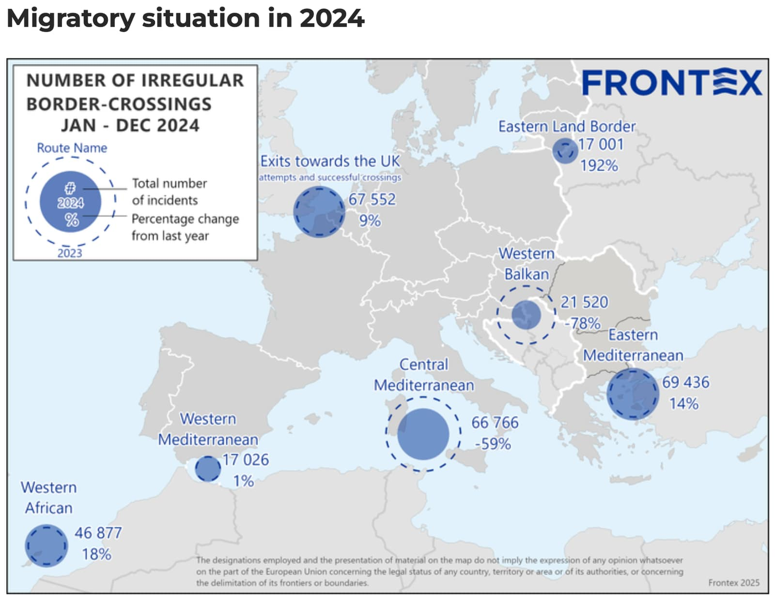
(Universidad de Navarra) Figure 2

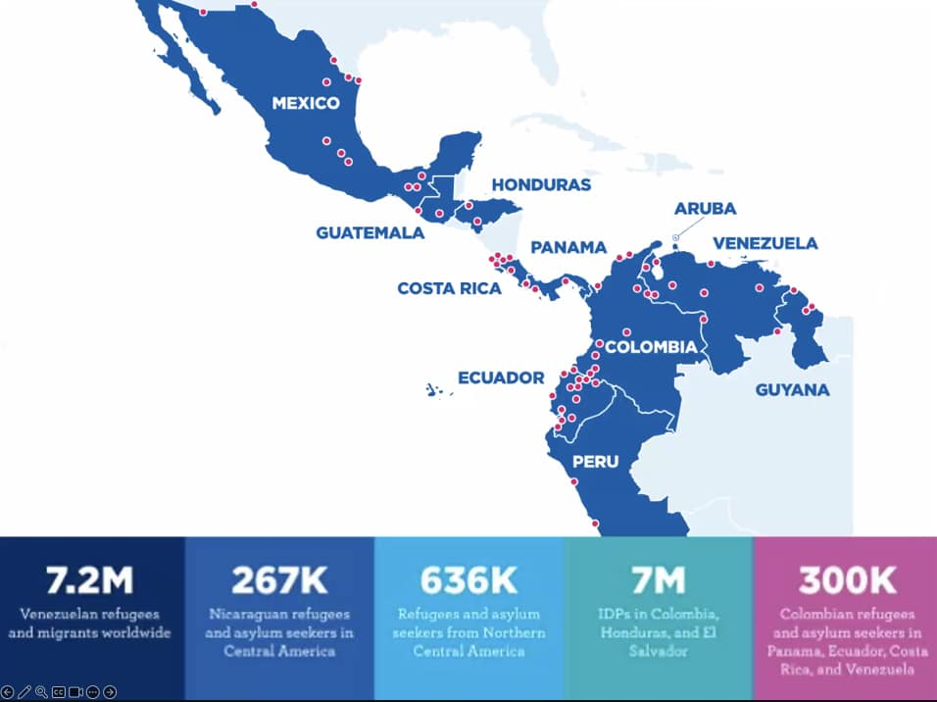
(IF2 G20 Interfaith Forum) Figure 3

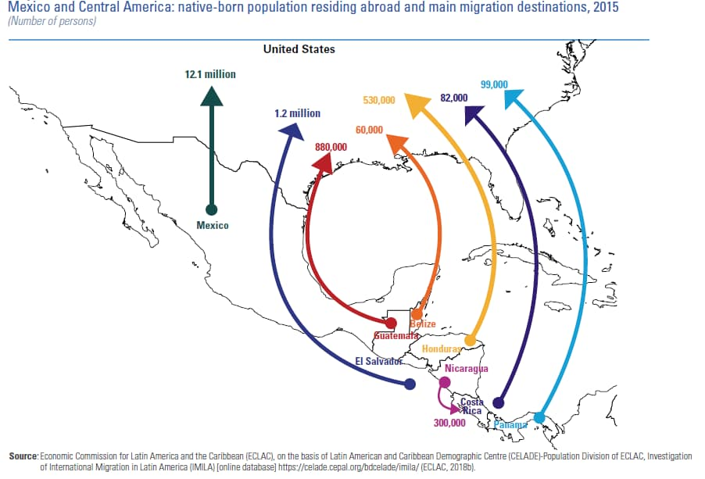
(Italian Institute for International Political Studies) Figure 4

Timeline

1951 | The 1951 Refugee Convention is adopted by the United Nations, which states the legal definition of a refugee and outlines the rights of displaced people as well as the obligation of states to protect them.
1967 | The 1967 Protocol Relating to the Status of Refugees removes the Convention’s limitations related to location and duration, to expand refugee protection worldwide
2015 | Europe experiences a major migration crisis, with over one million migrants and refugees arriving through the Mediterranean Sea, placing extreme pressure on European humanitarian services and asylum systems.
2016 | The New York Declaration for Refugees and Migrants is unanimously adopted by the UN General Assembly, committing the Member States to strengthen international cooperation when addressing large movements of migrants and refugees.
2018 | The Global Compact for Safe, Orderly and Regular Migration (GCM) is adopted by the UN, becoming the first intergovernmentally negotiated framework that covers all dimensions of international migration
2021 | The number of migrants crossing the Darién Gap, a dangerous jungle passage between Colombia and Panama, surged to a record 133,726 voyagers, making it one of the most prevalent routes for migrants traveling towards the United States.
2023 | Record numbers of migrants are reported on both the Central Mediterranean Route (157,479 crossings) and through the Darién Gap (520,085 migrants).
2024 | International organisations including the UNHCR and IOM, call for an increase in regional cooperation, expansion in legal migration pathways and stronger protection measures as  migration pressures continue to grow along both routes.

Major Parties

Italy, Greece & Spain – As major countries in the Mediterranean region, these countries receive large amounts of refugees and asylum seekers arriving by sea. They have called for greater EU-burden sharing, while strengthening border management and reception systems

United States– One of the main destination countries for migrants travelling through Latin America. It has implemented border enforcement and asylum policies in response to increased migration.
Mexico & Guatemala – Transit countries that cooperate to manage migration flows towards the United States.
Libya & Tunisia – Key departure points along the Mediterranean Route and central to efforts addressing smuggling and departures
Venezuela, Syria, Afghanistan & Sudan – Major countries of origin whose humanitarian and political crises have contributed to large-scale displacement
Morocco & Turkey – Significant transit countries connecting migrants to Europe through the Western and Eastern Mediterranean routes.
UNHCR & IOM – The principal international organizations coordinating protection, humanitarian assistance, and migration management.

Possible Solutions
The General Assembly should work in full cooperation to address the increase in migration through American and Mediterranean routes. Member States should focus on both short and long-term solutions to address global migration. This could include expanding legal migration pathways, such as humanitarian visas and work permits, while simultaneously strengthening regional cooperation agreements to improve burden-sharing and coordinated migration management. Efforts should also focus on increasing search-and-rescue operations, fighting against human trafficking networks and improving protection in transit countries. To sustain these solutions for a longer term, addressing root causes of migration such as conflict, poverty, and climate change through development aid is essential to reduce irregular migration flows.

Committee Objective
The goal of the General Assembly is to foster productive discussion on a wide range of global issues amongst member states, with a particular focus on global migration and access to minerals. By examining the causes, consequences and existing international frameworks that have been set in place, the committee aims to develop practical and long-term solutions that balance justice with international cooperation. Bearing in mind the diverse interests, responsibilities and circumstances of each nation, delegates should analyse existing laws, treaties and accords to better prepare new strategies and solutions for the future of migration and mineral access.

Sources

European Parliament. “Migration in the EU: Facts and Figures.” European Parliament, 30 Jan. 2025, https://www.europarl.europa.eu/topics/en/article/20170629STO78630/migration-in-the-eu-facts and-figures. Accessed 16 June 2026.
Frontex. “Central Mediterranean Top Migratory Route into the EU in First Half of 2023.” Frontex, 14 July 2023, https://www.frontex.europa.eu/media-centre/news/news-release/central-mediterranean-top-migra tory-route-into-the-eu-in-first-half-of-2023-XtMpdL. Accessed 16 June 2026.
International Organization for Migration. Missing Migrants Project. https://missingmigrants.iom.int/. Accessed 16 June 2026.
International Organization for Migration. World Migration Report.
https://worldmigrationreport.iom.int/. Accessed 16 June 2026.
International Organization for Migration. “Central Mediterranean Route.” Displacement Tracking Matrix Global Overview of Migration Routes,
https://dtm.iom.int/global-overview-of-migration-routes-portal/central-mediterranean. Accessed 16 June 2026.
International Organization for Migration. “Migrant and Refugee Movements through the Central Mediterranean Sea: Joint Annual Overview 2023.” Displacement Tracking Matrix, 10 June 2024, https://dtm.iom.int/reports/migrant-and-refugee-movements-through-central-mediterranean-sea-j oint-annual-overview-2023. Accessed 16 June 2026.
International Organization for Migration. Migration Data Portal: Irregular Migration. https://www.migrationdataportal.org/handbooks/chapter-4-introduction-key-concepts-and-definit ions/irregular-migration. Accessed 16 June 2026.

United Nations. Global Compact for Safe, Orderly and Regular Migration. https://www.un.org/en/migration2022/global-compact-for-migration. Accessed 16 June 2026.
United Nations. Sustainable Development Goals. https://sdgs.un.org/goals. Accessed 16 June 2026.
United Nations General Assembly. New York Declaration for Refugees and Migrants. 19 Sept. 2016,
https://www.un.org/en/development/desa/population/migration/generalassembly/docs/globalcom pact/A_RES_71_1.pdf. Accessed 16 June 2026.

United Nations High Commissioner for Refugees. 1951 Refugee Convention. https://www.unhcr.org/1951-refugee-convention.html. Accessed 16 June 2026.
United Nations High Commissioner for Refugees. Americas Situation. https://www.unhcr.org/emergencies/americas-situation. Accessed 16 June 2026.
United Nations High Commissioner for Refugees. Darién Gap Emergency Response. https://www.unhcr.org/what-we-do/where-we-work/americas/darien-gap-emergency-response. Accessed 16 June 2026.
United Nations High Commissioner for Refugees. Global Trends Report.
https://www.unhcr.org/global-trends. Accessed 16 June 2026.
United Nations High Commissioner for Refugees. Mediterranean Situation. https://data.unhcr.org/en/situations/mediterranean. Accessed 16 June 2026.
United Nations High Commissioner for Refugees. “Europe Sea Arrivals.” UNHCR Operational Data Portal, https://data.unhcr.org/en/situations/europe-sea-arrivals?id=211. Accessed 16 June 2026.
United Nations High Commissioner for Refugees. “The Sea Route to Europe: The Mediterranean Passage in the Age of Refugees.”
https://www.unhcr.org/us/media/sea-route-europe-mediterranean-passage-age-refugees. Accessed 16 June 2026.
Taylor, Luke. “Record Half Million People Crossed the Treacherous Darién Gap in 2023.” The Guardian, 3 Jan. 2024,
https://www.theguardian.com/us-news/2024/jan/03/record-half-million-people-crossed-darien-ga p-2023. Accessed 16 June 2026.

