Issue Report
Forum: UN World Health Organisation
Issue 2: The question of improving global preparedness, vaccine distribution, and healthcare infrastructure to combat Ebola virus disease and outbreaks
Chairs: Max Raskin & Victoria Cobarro

The question of improving global preparedness, vaccine distribution, and healthcare infrastructure to combat Ebola virus disease and outbreaks

Videos
- Ebola vaccination in practice course - Introduction
- Module 2: Ebola outbreak management cycle
- Module 3: Introduction to Ebola vaccines
- Module 5: Ring vaccination for Ebola virus disease
- Module 8: Organizing Ebola vaccination sessions
- Module 12: ICG Ebola vaccine stockpile
- LIVE: Launch of the Ebola Continental Strategic Preparedness and Response Plan
- Africa CDC Special Emergency Briefing: Ebola
- Screening Patients for Ebola Risk Factors and Symptoms
- Considerations for Preparedness
- Ebola Preparedness Exercise | UCLA Health
Articles
- Ebola Disease Fact Sheet (WHO)
- Ebola Virus Disease Vaccines (WHO)
- Ebola Vaccine Product Information (CDC)
- Ebola Vaccine Administration (CDC)
- Use of Ebola Vaccines Worldwide, 2021–2023 (CDC MMWR)
- Ebola Outbreak: Current Situation (CDC)
- Factsheet about Ebola Disease (ECDC)
- UNICEF, WHO, IFRC and MSF Announce the Establishment of a Global Ebola Vaccine StockpileEbola Then and Now: Eight Lessons from West Africa (WHO)
- Ebola Vaccine Stockpiles (WHO / ICG)
- Ebola Then and Now: Eight Lessons from West Africa (WHO)
- Overview, Control Strategies, and Lessons Learned in the CDC Response to the 2014–2016 Ebola Epidemic (CDC MMWR)
- Blind Spots Could Hide Full Spread of Congo’s Ebola Outbreak (Reuters)

Key Terms

Epidemic: outbreak of a disease

Contact Tracing: process that monitors people who have been exposed to or in contact with infected patients

Isolation: separation of uninfected and infected people

Ring Vaccination: strategy where people who had contact with an Ebola patient, and people who had contact with these contacts, are vaccinated

Cold Chain: system used to ensure that correct temperatures are maintained during vaccination storage and transport

Infection Prevention and Control (IPC): measures in hospitals implemented to prevent the spread of disease

Case Fatality Rate: percentage of people who die from the disease

Safe Burial Practices: procedures to bury people with the disease without spreading the virus

Cross-border Transmission: spread of disease from one country to another

Public Health Emergency of International Concern (PHEIC): health event declared by the WHO for when a disease spreads internationally

Vaccine Stockpile: storage of vaccines so that they can be used immediately when needed

Vaccine Equity: idea that vaccines should be distributed equally and fairly

Overview

The Ebola Virus Disease (EVD) is a condition that is characterized by severe bleeding, organ failure, and systemic inflammation [World Health Organization, “Ebola Disease,” 2025]. Since its discovery in the late 20th century in the DEmocratic Republic of Congo, the Ebola Virus has spread throughout multiple countries in central and western Africa, placing pressure on hospitals, governments, laboratories, communities, and health workers —and of course, resulting in thousands of deaths [World Health Organization, “Ebola Disease,” 2025]. However, concerns have arisen about whether the main damage caused by this condition is the virulence of the disease or the weak outbreak control that accompanies it. It has since spread to Mali, Nigeria, South Sudan, Guinea, Senegal, and Congo, among others [Centers for Disease Control and Prevention, “Outbreak History,” 2026].

Many of the affected regions lack the necessary infrastructure and technology to fight this disease —including the lack of trained healthcare workers, isolation units, laboratories, ambulances, and protective equipment [World Health Organization, “Ebola Then and Now,” 2024]. Furthermore, the lack of modern surveillance methods can delay the detection of new Ebola cases, further contributing to its destructive nature [Centers for Disease Control and Prevention, “Outbreak History,” 2026]. This, paired with the fact that most of these outbreaks happen in low-income countries, many of which have regional conflicts or political instabilities, has made it difficult for the few healthcare workers to reach their appointed hospitals [World Health Organization, “Ebola Then and Now,” 2024]. And yet, for years, its contagious nature (specifically, EVD is transmitted via direct contact of bodily fluids, such as blood, saliva, or other naturally occurring biofluids) has meant that it has spread rapidly during these outbreaks [World Health Organization, “Ebola Disease,” 2025],
Thus, the UN has worked to both manage the effects of the disease itself and to control its spread. These strategies were most evident in the 2014-2016 West Africa outbreak, the largest Ebola outbreak in history [World Health Organization, “Ebola Virus Disease,” 2025].
In September 2014, the UN created the United Nations Mission for Ebola Emergency Response (UNMEER) to help affected countries stop transmission, treat infected patients, maintain essential services, support stability, and prevent future outbreaks [United Nations, “Statement by the Secretary-General on the Establishment of UNMEER,” 2014]. This way, the United Nations, alongside the WHO, were able to prevent any further damage by consulting with local governments. Specifically, this was performed by actions such as surveillance, contact tracing, isolation of infected patients, safe burials, community education, and infection prevention in hospitals [United Nations, “Statement by the Secretary-General on the Establishment of UNMEER,” 2014]. Another key UN-backed strategy was improving vaccine access. This was put into action by establishing a global Ebola vaccine stockpile, meaning that up to 500,000 doses of Ebola vaccines were available at any given time [World Health Organization, “Ebola Vaccine Stockpiles,” 2025].

Statistics & Infographics

The following page can be used to find some accurate and updated information about the Ebola Virus and its outbreaks throughout the 20th and 21st centuries. History of Ebola Outbreaks

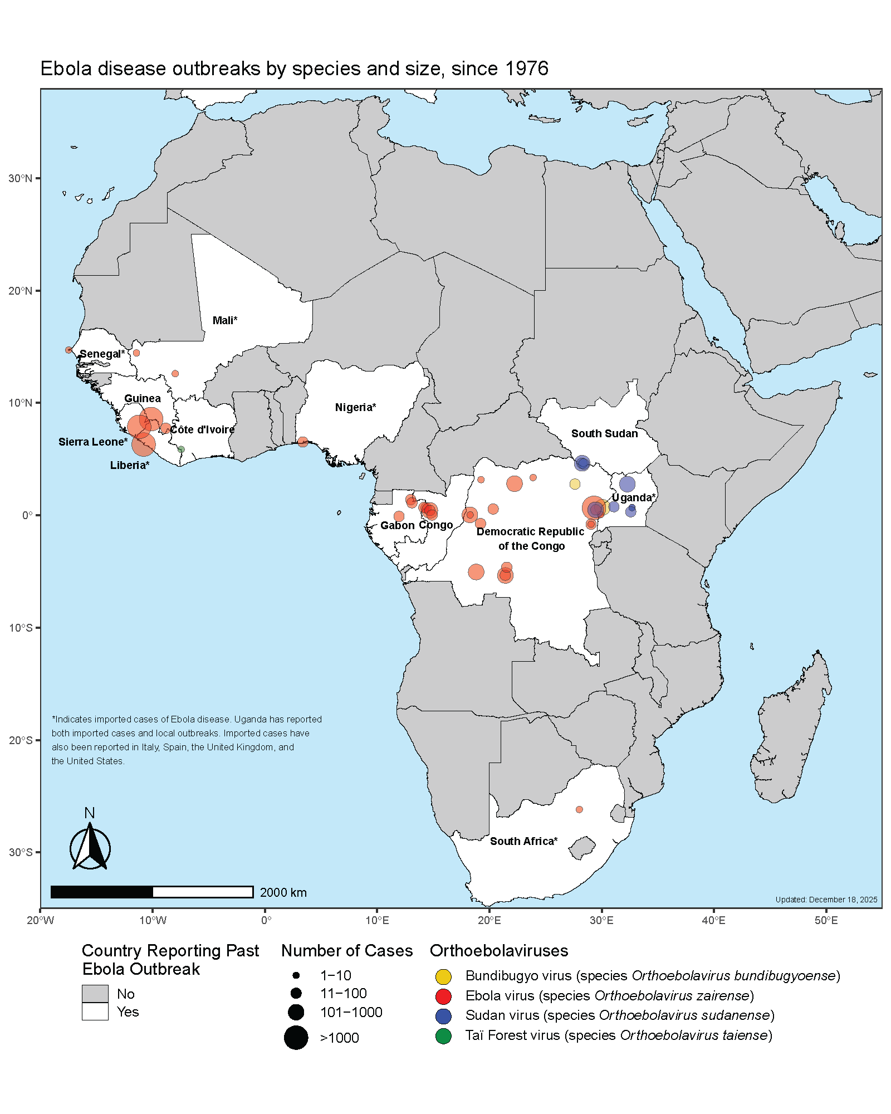
(CDC, 2026) Figure 1

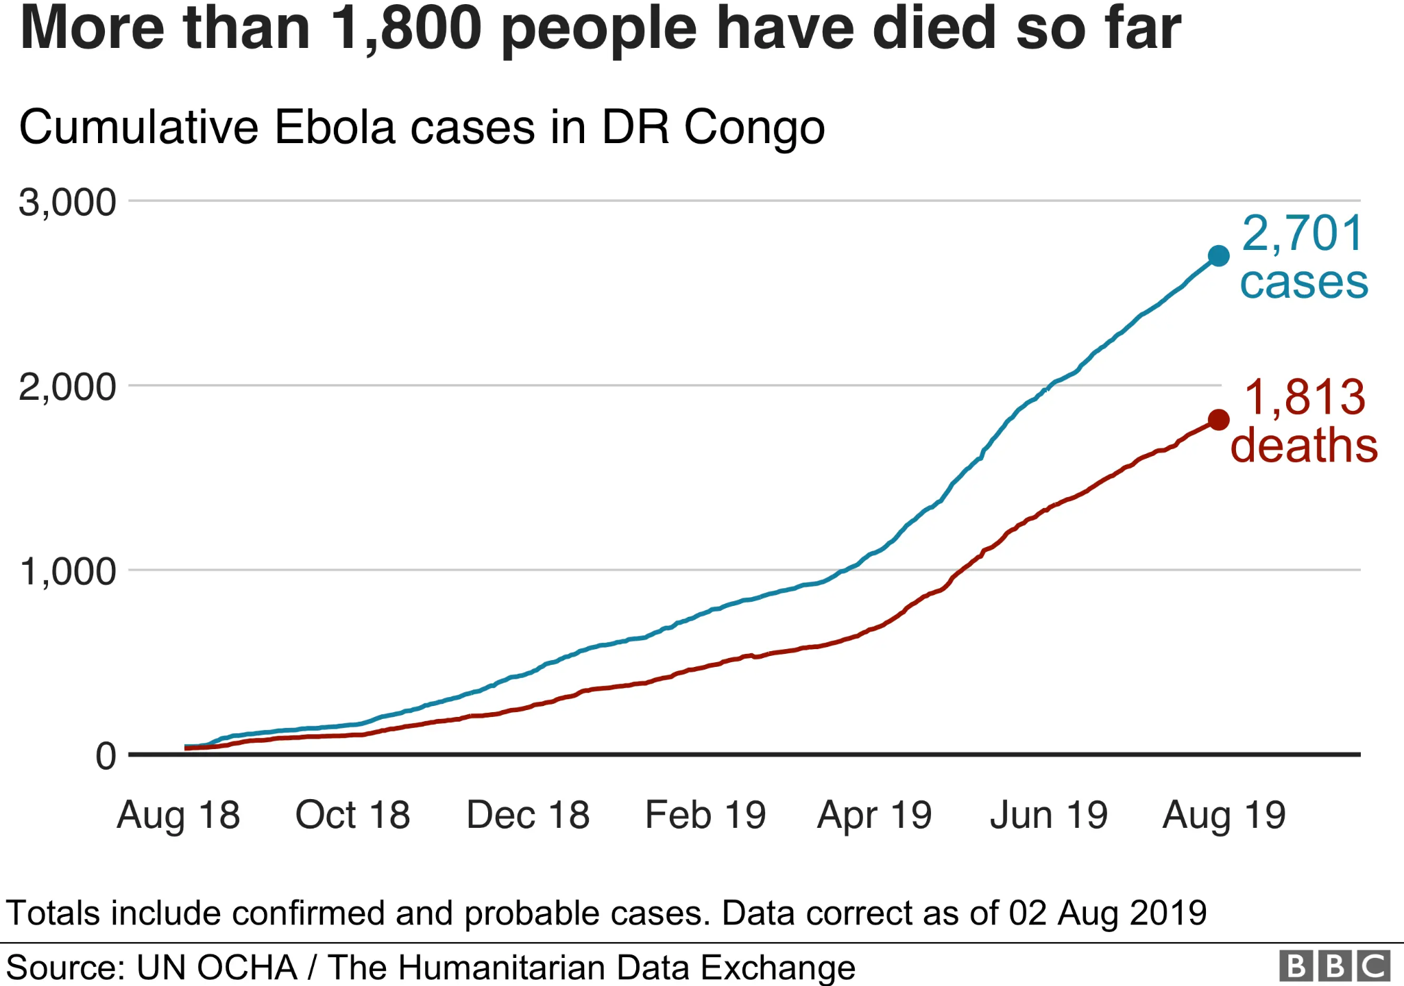
(BBC, 2019) Figure 2

Timeline

1976 | Outbreaks near the Ebola river in the Democratic Republic of Congo and in South Sudan
1995 | A major Ebola outbreak occurs in Kikwit, Democratic Republic of the Congo
2001-2002 | Outbreak in Uganda
2014 | WHO declares the outbreak a Public Health Emergency of International Concern
2014 | The UN creates the United Nations Mission for Ebola Emergency Response (UNMEER)
2014-2016 | Largest outbreak ever recorded in West Africa
2018 | Ebola vaccines are deployed immediately after an outbreak in the Democratic Republic of Congo
2021 | WHO, UNICEF, IFRC, and MSF create a global Ebola vaccine stockpile

Major Parties

World Health Organization (WHO) - The main international body ensuring that the Ebola response is effective. It is responsible for alerting governments about outbreaks, vaccination, giving them guidance, surveillance, and much more

Democratic Republic of the Congo (DRC) - One of the countries most affected by Ebola.

United Nations Children’s Fund (UNICEF) - responsible for vaccine delivery, hygiene campaigns, education about the disease, and child protection.

The United States / CDC - the world’s leading nation in healthcare technologies, provides outbreak support, funding, and research into vaccines and outbreak prevention strategies.

European Union / ECDC - Much like the United States, it provides financial support and public health guidance to affected countries.

Possible Solutions

The World Health Organisation at RCMUN 2026 should be in full cooperation to find solutions, working to ensure safe and controlled Ebola outbreaks. The United Nations should work to ratify and reaffirm past agreements regarding the Ebola Virus classification, while ensuring that all affected countries are kept out of harm's way. The strategies to deal with Ebola outbreaks must be amended, and the financial responsibility must be divided in a fair and equitable manner. With this, solutions should bear in mind the United Nations Sustainable Development Goals, and include these in proposed resolutions.

Committee Objective

The goal of the World Health Organization at RCMUN 2026 is to foster productive discussion about the growing issue of dealing with the Ebola Virus. By noting major parties, possible outcomes and effects, and the impact of this issue, the committee hopes to develop long-lasting solutions that all nations can benefit from and agree upon. Bearing in mind all parties and their motives, the committee should strive for a fruitful debate, working towards a common solution.

Sources

Africa Centres for Disease Control and Prevention. “Ebola Virus Disease.” Africa CDC. Accessed June 18, 2026. https://africacdc.org/disease/ebola-virus-disease/.
Centers for Disease Control and Prevention. “Ebola Disease Basics.” CDC. Accessed June 18, 2026. https://www.cdc.gov/ebola/about/index.html.
Centers for Disease Control and Prevention. “Ebola Outbreak: Current Situation.” CDC. Accessed June 18, 2026. https://www.cdc.gov/ebola/situation-summary/index.html.
Centers for Disease Control and Prevention. “Ebola Vaccine Product Information.” CDC. Accessed June 18, 2026. https://www.cdc.gov/ebola/hcp/vaccines/index.html.
Centers for Disease Control and Prevention. “History of Ebola Outbreaks.” CDC. Accessed June 17, 2026. https://www.cdc.gov/ebola/outbreaks/index.html.
Centers for Disease Control and Prevention. “Overview, Control Strategies, and Lessons Learned in the CDC Response to the 2014–2016 Ebola Epidemic.” Morbidity and Mortality Weekly Report 65, no. 3 (2016). https://www.cdc.gov/mmwr/volumes/65/su/su6503a2.htm.
Centers for Disease Control and Prevention. “Use of Ebola Vaccines Worldwide, 2021–2023.” Morbidity and Mortality Weekly Report 73, no. 16 (2024). https://www.cdc.gov/mmwr/volumes/73/wr/mm7316a1.htm.
European Centre for Disease Prevention and Control. “Factsheet about Ebola Disease.” ECDC. Accessed June 17, 2026. https://www.ecdc.europa.eu/en/infectious-disease-topics/ebola-disease/disease-information/factsheet-about-ebola-disease.
Gavi, the Vaccine Alliance. “500,000 Doses of Ebola Vaccine to Be Made Available to Countries for Outbreak Response.” Gavi. Accessed June 18, 2026. https://www.gavi.org/news/media-room/500000-doses-ebola-vaccine-be-made-available-countries-outbreak-response.
International Federation of Red Cross and Red Crescent Societies. “UNICEF, WHO, IFRC and MSF Announce the Establishment of a Global Ebola Vaccine Stockpile.” IFRC, January 12, 2021. https://www.ifrc.org/press-release/unicef-who-ifrc-and-msf-announce-establishment-global-ebola-vaccine-stockpile.
Médecins Sans Frontières. “Ebola.” MSF. Accessed June 18, 2026. https://www.msf.org/ebola.
National Library of Medicine. “Global Health Security: The Wider Lessons from the West African Ebola Virus Disease Epidemic.” PMC. Accessed June 17, 2026. https://pmc.ncbi.nlm.nih.gov/articles/PMC5856330/.
United Nations. “The Mission to Stop Ebola: Lessons for UN Crisis Response.” United Nations Academic Impact. Accessed June 18, 2026. https://www.un.org/en/academic-impact/mission-stop-ebola-lessons-un-crisis-response.
United Nations. “Statement by the Secretary-General on the Establishment of the United Nations Mission for Ebola Emergency Response (UNMEER).” September 19, 2014. https://www.un.org/sg/en/content/former-secretary-general/statements/2014-09-19/statement-the-secretary-general-the-establishment-of-the-united-nations-mission-for-ebola-emergency-response-%28unmeer%29.
United Nations Children’s Fund. “Making Strides in the Fight against Ebola Virus.” UNICEF Supply Division. Accessed June 18, 2026. https://www.unicef.org/supply/stories/making-strides-fight-against-ebola-virus.
World Health Organization. “Ebola Disease.” WHO, April 24, 2025. https://www.who.int/news-room/fact-sheets/detail/ebola-disease.

World Health Organization. “Ebola Then and Now: Eight Lessons from West Africa.” WHO. Accessed June 18, 2026. https://www.who.int/news-room/feature-stories/detail/ebola-then-and-now.
World Health Organization. “Ebola Vaccine Stockpiles.” WHO. Accessed June 17, 2026. https://www.who.int/groups/icg/ebola-virus-disease/ebola-stockpiles.
World Health Organization. “Ebola Virus Disease Vaccines: Questions and Answers.” WHO. Accessed June 18, 2026. https://www.who.int/news-room/questions-and-answers/item/ebola-vaccines.
World Health Organization. “Ebola Outbreak 2014–2016 — West Africa.” WHO. Accessed June 18, 2026. https://www.who.int/emergencies/situations/ebola-outbreak-2014-2016-West-Africa.
World Health Organization. “UNICEF, WHO, IFRC and MSF Announce the Establishment of a Global Ebola Vaccine Stockpile.” WHO, January 12, 2021. https://www.who.int/news/item/12-01-2021-unicef-who-ifrc-and-msf-announce-the-establishment-of-a-global-ebola-vaccine-stockpile.

