Issue Report
Forum: UN General Assembly
Issue 2: The question of ensuring global access to critical minerals needed for renewable energy technologies - lithium child labour
Chairs: Hana Raskin & Madeleine Cabana

The question of ensuring global access to critical minerals needed for renewable energy technologies - lithium child labour

Videos
- Child labour: Nigeria’s lithium mines reveal the dark side of our electric future
- CBS News finds children mining cobalt in Democratic Republic of Congo
- Launch of the UN Secretary-General's Panel on Critical Energy Transition Minerals
Articles
- Report SG Panel On Critical Energy Transition Minerals
- Child Labour Behind Smart Phone and Electric Car Batteries
- Lithium Mining Energy Transition Child Labour Nigeria Africa
- What are Critical Minerals and Why do they Matter for Human Rights
- ILO Bangkok Manila Publications
- Critical Minerals Critical Decisions Industrial Policy Energy Transition

Key Terms

Child Labour: Work that deprives children of their childhood, their potential and their dignity, and that is harmful to their physical and mental development.

ILO: Organisation that is devoted to promoting social justice and internationally recognised human and labour rights, pursuing its founding mission that social justice is essential to universal and lasting peace.

Renewable Energy technologies: Renewable energy technologies are converters of Earth’s ecosystem energy into energy products. Examples of energy technologies included are biomass, wind, solar, hydropower, geothermal, marine energies converters.

Artisanal and Small-Scale Mining: Small-scale mining often carried out by individuals or local groups, which the report says should be made safer, legal, formal and free from exploitation or child labour.

Benefit Sharing: Making sure the profits and advantages from mineral extraction are fairly shared with local communities, workers and mineral-producing countries.

Energy Transition: The global shift away from fossil fuels towards renewable energy sources such as solar, wind and hydropower.

Lithium: A critical mineral used mainly in rechargeable batteries for electric vehicles, phones and renewable energy storage.

Critical Minerals: Minerals that are essential for modern technologies and energy systems but may be difficult to access because of limited supply, geopolitical risk or high demand.

Energy Justice: The idea that the benefits and burdens of the energy transition should be shared fairly, especially between rich and developing countries.

Overview

The worldwide shift from fossil fuels to renewable energy has made vital minerals key. The world is moving away from fuels and towards renewable energy and this has made certain minerals very important for our planet's climate policy. Things like cars, solar panels and wind turbines need minerals such as lithium, cobalt and copper to work. Lithium is particularly important because it is used a lot in batteries that can be recharged, which are necessary for cars and storing renewable energy.
As countries try to reduce the things they release into the air and meet their climate goals the demand for these minerals is going up fast. This means that getting reliable access to these minerals is a big issue for the whole world.
The problem is that these minerals are not found everywhere. Many of the places with a lot of these minerals are not as rich as countries and they need to be careful not to just sell the raw minerals to other countries. If they do, those other countries will get most of the benefits from turning the minerals into things.. If the countries with a lot of minerals can handle them in a good way it could help their economies grow, create jobs and make their industries stronger.
The situation is very serious because some of the ways that minerals are obtained are very harmful for people. For example, some places where minerals are mined use children to do the work. These children may have to dig, carry, clean or sort minerals in horrible conditions. This can hurt them physically, expose them to chemicals and make them work too much which can also stop them from going to school. The fact that children are used to mining minerals is a problem for people who want to make the world a cleaner place because

it means that some of the new technologies that are supposed to help the planet are actually using methods that are increasingly harmful.
The world needs lithium and other minerals like cobalt and copper to make the transition to energy. These minerals are crucial for cars, solar panels and wind turbines. Lithium is especially important for batteries, which are necessary for electric cars and renewable energy storage, so the demand for this mineral specifically is rising fast. It is a large issue for the world to get fair and reliable access to them. Minerals like lithium, cobalt and copper are essential for the world's climate policy, and so the world needs to find a way to obtain them in a responsible and sustainable way.
Issues related to the environment further complicate this matter. Extracting and refining essential minerals may lead to water contamination, forest destruction, loss of biodiversity, soil deterioration, and significant waste generation. The extraction of lithium can exert pressure on water supplies, particularly in areas already experiencing drought or water shortages. These effects frequently affect local communities and Indigenous Peoples the most, particularly those whose territories hold valuable mineral resources.
Consequently, the discussion revolves not just around obtaining sufficient minerals, but also around safeguarding ecosystems, community rights, and enduring sustainability.Thus, this committee must evaluate how the international community can guarantee worldwide access to essential minerals required for renewable energy technologies while avoiding exploitation and uneven development. Delegates must reconcile the pressing demand for climate action with the necessity of safeguarding children, workers, local communities, and the environment. The main challenge is to ensure that the energy transition is not only swift but also equitable, moral, and sustainable.

Statistics & Infographics
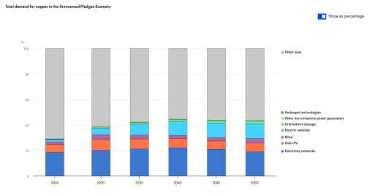https://www.iea.org/data-and-statistics/data-tools/critical-minerals-data-explorer
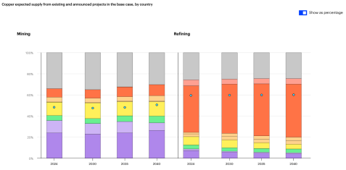https://www.iea.org/data-and-statistics/data-tools/critical-minerals-data-explorer
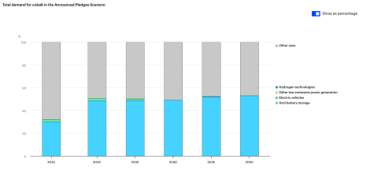https://www.iea.org/data-and-statistics/data-tools/critical-minerals-data-explorer
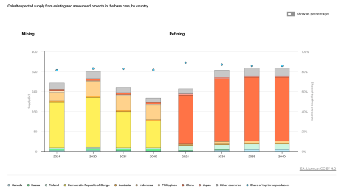https://www.iea.org/data-and-statistics/data-tools/critical-minerals-data-explorer
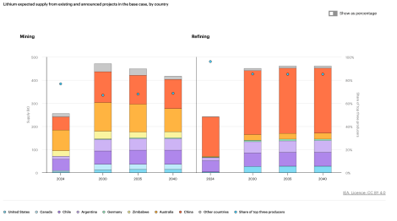https://www.iea.org/data-and-statistics/data-tools/critical-minerals-data-explorer
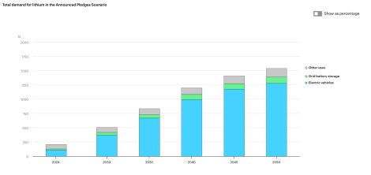https://www.iea.org/data-and-statistics/data-tools/critical-minerals-data-explorer
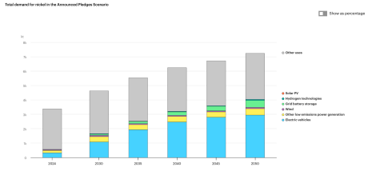https://www.iea.org/data-and-statistics/data-tools/critical-minerals-data-explorer
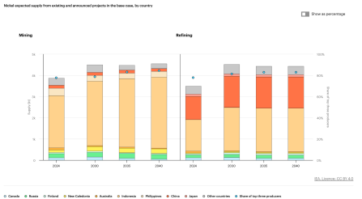https://www.iea.org/data-and-statistics/data-tools/critical-minerals-data-explorer 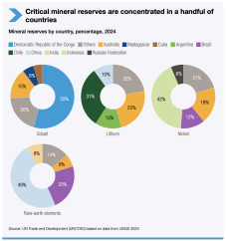
https://unctad.org/publication/critical-minerals-critical-decisions-industrial-policy-energy-transition

Major Parties

Democratic Republic of Congo - Country that mines lots of cobalt, which is a mineral that is used in most lithium-ion batteries. It is also strongly linked to child labour problems.

Indonesia - Is important because it is a major nickel producer, something that is used in many electric vehicle batteries. It is an example of a country that portrays how producer countries are processing minerals domestically instead of only exporting raw materials/ minerals.

Chile, Argentina and Bolivia - Major lithium-producing or lithium-rich countries in South America, so they are essential for battery supply chains.

China - Dominates the refining and processing of critical minerals, like lithium, cobalt or nickel (even when the minerals are mined elsewhere). This therefore makes China hold major influence over global battery, electric vehicle and renewable energy supply chains.

United States of America - The United States consumes electric vehicles, batteries and clean energy technologies very much. It also urges supply chains to reduce dependence on China and prevent child labour.

ILO - It focuses on workers’ rights, child labour, forced labour and safe working conditions. ILO is especially relevant because mining supply chains can involve dangerous labour conditions and exploitation of children.

IEA - It provides data and analysis on how many minerals are needed for renewable energy technologies, batteries and electric vehicles. It helps countries understand supply risks, demand growth and why minerals such as lithium, cobalt, nickel and rare earths are strategically important.

OECD - Gives guidance on responsible mineral supply chains and due diligence. Its work helps governments and companies check whether minerals are linked to child labour, conflict, forced labour or other human rights abuses.

Possible Solutions

The UN General Assembly should be in full cooperation to find solutions working to ensure that global access to critical minerals remains fair, sustainable and free from child labour. The United Nations ought to create a council that oversees the responsible sourcing of minerals such as lithium, cobalt, nickel and copper, while also monitoring whether companies and governments are respecting human rights in mining communities. Furthermore, Members in the council should openly discuss the extent of creating campaigns to raise awareness about child labour in mineral supply chains, and on what platforms this information will be accessible, and for whom. Keeping in mind the needs of both mineral-producing and mineral-consuming nations, the UN General Assembly will create a solution benefiting the global community while supporting the renewable energy transition. Lastly, the United Nations should establish the need for humanitarian aid, education programmes and safer employment opportunities in mining regions so that children are protected from exploitation while families are not left without support.

Committee Objective

The goal of the General Assembly is to foster productive discussion on a wide range of global issues amongst member states, with a particular focus on global migration and access to minerals. By examining the causes, consequences and existing international frameworks that have been set in place, the committee aims to develop practical and long-term solutions that balance justice with international cooperation. Bearing in mind the diverse interests, responsibilities and circumstances of each nation, delegates should analyse existing laws, treaties and accords to better prepare new strategies and solutions for the future of migration and mineral access.

Sources
Amnesty International. “Child Labour Behind Smart Phone and Electric Car Batteries.” Amnesty International, 19 January 2016.
https://www.amnesty.org/en/latest/news/2016/01/child-labour-behind-smart-phone-and-electric-c ar-batteries/
Amnesty International. “What Are Critical Minerals and Why Do They Matter for Human
Rights?” Amnesty International, 10 June 2026.
https://www.amnesty.org/en/latest/campaigns/2026/06/what-are-critical-minerals-and-why-do-the y-matter-for-human-rights/
Associated Press. “In Nigeria’s Lithium Boom, Many Mines Are Illegal and Children Do Much of the Work.” AP News, 12 December 2024.
https://apnews.com/article/lithium-mining-energy-transition-child-labor-nigeria-africa-22155590 dddf7ecc0b9fd55b221c6d9f
International Energy Agency. “Critical Minerals.” IEA.
https://www.iea.org/topics/critical-minerals
International Energy Agency. “Critical Minerals Data Explorer.” IEA, 2025. https://www.iea.org/data-and-statistics/data-tools/critical-minerals-data-explorer
International Energy Agency. Global Critical Minerals Outlook 2025. IEA, May 2025. https://www.iea.org/reports/global-critical-minerals-outlook-2025
International Labour Organization. “Child Labour in Mining and Global Supply Chains.” ILO, 23 September 2019. https://www.ilo.org/publications/child-labour-mining-and-global-supply-chains
International Labour Organization and UNICEF. Child Labour: Global Estimates 2024, Trends and the Road Forward. ILO and UNICEF, 2025.
https://www.ilo.org/publications/major-publications/child-labour-global-estimates-2024-trends-an d-road-forward
Organisation for Economic Co-operation and Development. OECD Due Diligence Guidance for Responsible Supply Chains of Minerals from Conflict-Affected and High-Risk Areas. OECD, 2016.
https://www.oecd.org/en/publications/2016/04/oecd-due-diligence-guidance-for-responsible-supply-chains-of-minerals-from-conflict-affected-and-high-risk-areas_g1g65996.html
Reuters. “G7 Sets Up Critical Minerals Alliance, Platform to Cut Reliance on China.” Reuters, 17 June 2026.
https://www.reuters.com/world/europe/g7-sets-up-critical-minerals-alliance-crisis-platform-2026- 06-17/

United Nations. Resourcing the Energy Transition: Principles to Guide Critical Energy Transition Minerals Towards Equity and Justice. United Nations, September 2024.
https://www.un.org/sites/un2.un.org/files/report_sg_panel_on_critical_energy_transition_mineral s_11_sept_2024.pdf
United Nations. “The UN Secretary-General’s Initiative on Critical Energy Transition Minerals.” United Nations. https://www.un.org/en/climatechange/critical-minerals
United Nations Environment Programme. “Resourcing the Energy Transition.” UNEP, 11
September 2024. https://www.unep.org/resources/report/resourcing-energy-transition
United Nations Trade and Development. “How Critical Energy Transition Minerals Can Pave the Way for Shared Prosperity.” UNCTAD, 12 November 2024.
https://unctad.org/news/blog-how-critical-energy-transition-minerals-can-pave-way-shared-prosp erity
UNICEF. “Child Labour Global Estimates 2024.” UNICEF Data, 11 June 2025. https://data.unicef.org/resources/child-labour-global-estimates-2024
U.S. Department of Labor. “Lithium-Ion Batteries Supply Chain.” Bureau of International Labor Affairs.
https://www.dol.gov/agencies/ilab/reports/child-labor/list-of-goods/supply-chains/lithium-ion-batteries

