Issue Report
Forum: UN Human Rights
Issue 2: The question of protecting journalists and freedom of the press in North East African Nations including: Eritrea, Djibouti, Ethiopia, Sudan and Egypt
Chairs: Ana Kanahuati and Atalanta Baéz

Protecting journalists and the freedom of the press in conflict zones
Videos
- Are Journalists Safe in War Zones? - Behind the News - YouTube
- Press Freedom In Africa: Ensuring The Safety Of Journalists | VSA | 03-05-23
- iMEdD - Journalists at War: Opening up about covering conflict zones
- Protecting Press Freedom: The Risks of Reporting in Gaza and Beyond -SDG Media Zone | United Nations
- World Press Freedom Day: Challenges, potential for journalism in Somalia and Africa
- 10 years of impact - UN Plan of Action to #ProtectJournalists - National Protection Mechanisms - YouTube
Articles
- Journalism, War, and Conflict: The International Journalism Handbook
- Digital warfare, censorship, and risks to journalists in conflict: finding a way forward - ARTICLE 19
- World Report 2025: Egypt | Human Rights Watch
- Amid declining press freedom globally, East African countries enter “very serious” territory
- Safety of Journalists in crisis and conflict-situations | UNESCO
- More than a story | United Nations
- Explore CPJ's database of attacks on the press
- Sudan’s Bad Laws, Internet Censorship and Repressed Civil Liberties copy

Key Terms

Journalism: the work of collecting, writing, and publishing news stories and articles in newspapers and magazines or broadcasting them on the radio and television (Cambridge Dictionary)

Freedom of the Press: refers to the right of journalists and press organisations to operate independently without censorship or interference from government authorities (UNESCO)

Democracy: a system of government in which power is held by elected representatives who are freely voted for by the people, or held directly by the people themselves. (Cambridge dictionary).

Censorship: a system in which an authority limits the ideas that people are allowed to express and prevents books, films, works of art, documents, or other kinds of communication from being seen or made available to the public, because they include or support certain ideas. (Cambridge dictionary)

Impunity: freedom from punishment or from the unpleasant results of something that has been done. (Cambridge Dictionary)

Digitalisation: the process of changing something such as a document to a digital form (= a form that can be stored and read by computers), or the use of digital technology to do something. (Cambridge Dictionary)

Overview

We can define journalism as the work of collecting, writing, and publishing news stories and articles in newspapers and magazines or broadcasting them on the radio and television. Journalists, particularly in conflict zones, play a crucial role in reporting war crimes firsthand, providing accurate and reliable information– especially in a time with such high distribution of images and videos intermingled with AI – and countering false propaganda.

They aid in holding criminal parties responsible for their war crimes and have described their job as “life-altering”. However, they face serious threats, risks and targeted attacks, raising serious human rights concerns and concerns about press freedom.

Over the past 30 years, a study from Behind the News found that more than 2,200 journalists and media workers have been killed reporting on war zones. Press freedom refers to the right of journalists and press organisations to operate independently without censorship

or interference from government authorities or other entities. Many Northeastern African Nations, such as Eritrea, maintain one of the most restrictive governments in terms of media restriction and censorship, prohibiting journalists from publishing their truths.

Many journalists face many challenges in ensuring they can safely report on the war crimes they notice, often facing detention, violence and censorship. In Sudan, the 2009 Press and Publications Act and press-council licensing regulations give control of the content published to major states. Recently, the danger of being a journalist has increased: in 2025, being ranked 156th of 180 in the World Press Freedom Index.

In recent years, Egypt has become one of the most controlled environments for media and the press. Law No. 180 of 2018 introduced significant regulations for journalists through the Supreme Council for Media Regulation, allowing the blocking of websites and punishing ‘false’ content.

Journalists continue facing censorship, judicial harassment and arrests. After 2018, Ethiopia's press environment changed significantly when reforms allowed independent journalism and the release of jailed journalists. Its constitution now legally protects freedom of expression, and the 2021 Media Proclamation introduced safeguards which decriminalised defamation. However, recently, reports show an increase in arrests, hacking and control over media regulation.

Key Challenges
- Violence against journalists
- Targeted attacks or violence
- Censorship
- Digital Repression
- Impunity

Statistics & Infographics
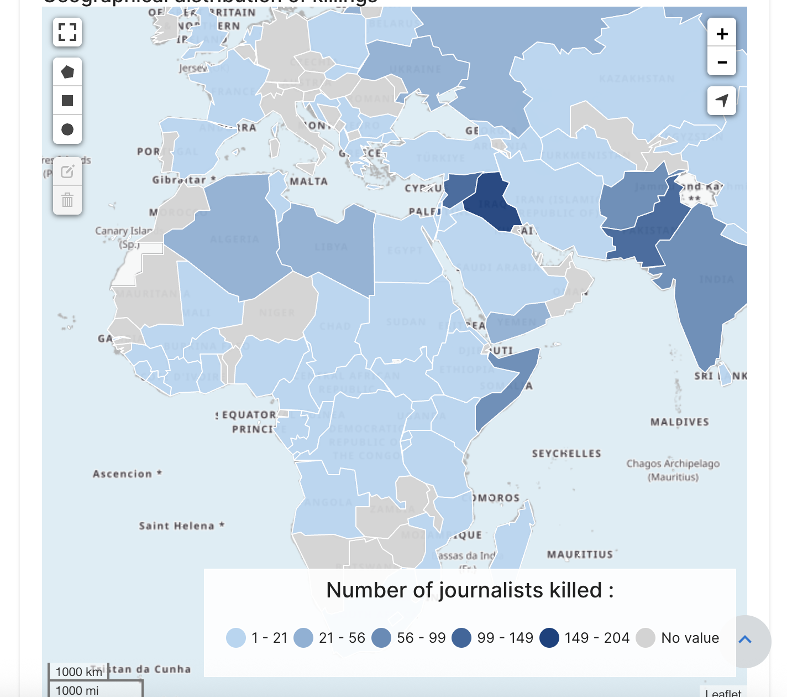
https://www.unesco.org/en/safety-journalists/observatory
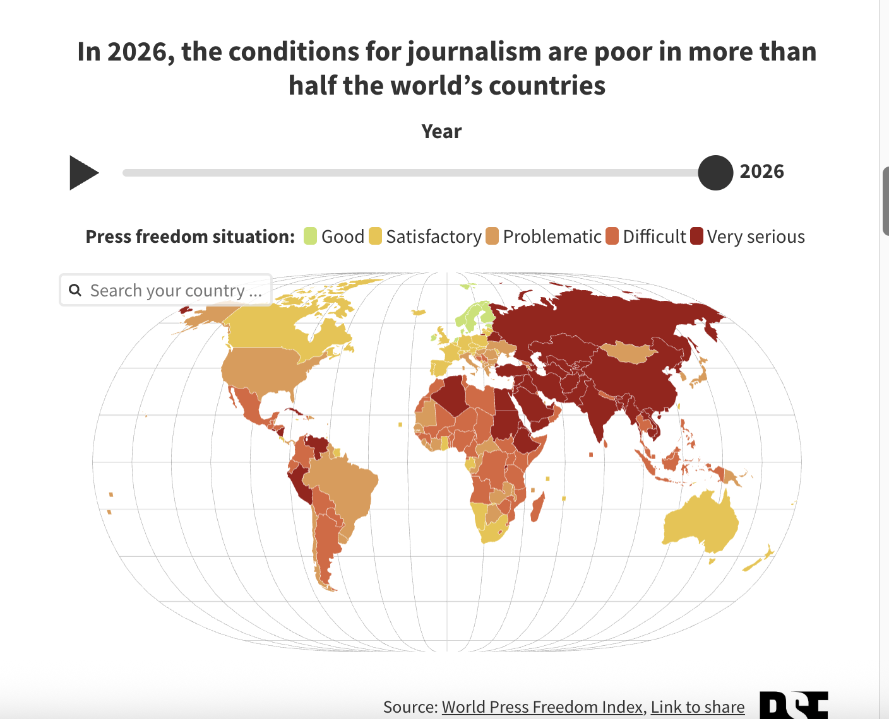
https://rsf.org/en/2026-rsf-index-press-freedom-25-year-low
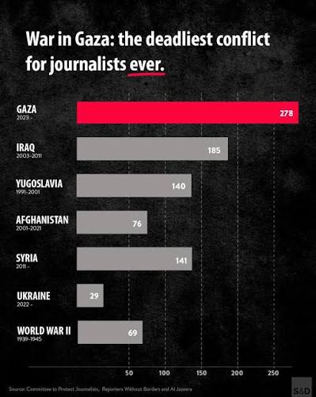

Timeline

1991 | Windhoek Declaration: Major African-led push for freedom of the press and media
2000s | Expansion and growth of digital media and online journalism
2011 | Arab Spring: regional protests demanding freedom of the press met with increased tightening of media control in some countries
2013 | Intensification of media restriction in Egypt: including arrests and censorship
2016–2022 | Ethiopia conflict escalation (Tigray region civil conflict): internet shutdowns, limitations on reporting and less access for journalists
2019 | Sudan faces political instability and armed conflict: journalists faced violence, displacement and safety risks
2010s | Digital repression of media and reporting: internet shutdowns, surveillance, censorship
2020s | Increased attacks and violence on journalists in war conflicts (Yemen, Sudan, Ethiopia, Somalia). Rise in global concerns around safety of journalists and impunity

Major Parties

United States – A key global advocate for press freedom with strong legal protections, though debates over misinformation and political pressure remain.
United Kingdom – Influential in shaping media policy and regulation, balancing press freedom with privacy laws.
China – One of the most restrictive media environments, with global influence over information control.
Russia – Increasing suppression of independent journalism, especially during wartime.
India – World’s largest democracy with growing concerns about press freedom and journalist safety.
Saudi Arabia – Highly controlled media system, often highlighted in international human rights discussions.
Iran – Strict censorship and frequent imprisonment of journalists critical of the regime.
Eritrea – Maintains one of the most restrictive media environments globally, with no independent press and frequent journalist detention
Afghanistan – Severe restrictions under Taliban rule; independent journalism is heavily suppressed.
Turkey – Major regional power with significant restrictions and arrests of journalists.
Afghanistan – Extreme suppression of media under Taliban rule.
Mexico – One of the most dangerous countries for journalists despite having a formally free press.
France – Strong press freedom protections and active role in international advocacy.
Germany – Promotes democratic media standards and combats disinformation in Europe

Possible Solutions:

The Human Rights Committee should cooperate fully to find effective solutions regarding the issues surrounding journalists in dangerous conflict zones and freedom of the press in North East African nations, including: Eritrea, Djibouti, Ethiopia, Sudan and Egypt. Delegates should openly discuss and explore measures which help improve journalists’ current situation and examine current legislation and frameworks, working together to address the concerns around them. Furthermore, solutions and proposals put forward by Member states should be evaluated, all while respecting the opinions and requests of all nations; the Human Rights Committee should develop a solution benefiting the global community. To do so better, delegates should collaborate with each other, propose competent solutions and respect differing opinions.

Committee Objective:

The goal of the Human Rights Committee is to, through Member States’ cooperation and discussion, form a solution to the issue at hand: the question of protecting journalists and freedom of the press in North East African Nations including: Eritrea, Djibouti, Ethiopia, Sudan and Egypt. Through a thorough disscusion of current legislation, the roles of major parties, past and current relevant events, and the global impact of the issue, this committee hopes to find a long-lasting solution. To achieve this, all delegates are strongly encouraged to participate.. All Nations are further encouraged to come up with strategies and laws, and collaborate with other Parties to strengthen their resolutions.

Sources

Behind the News (2025). Are Journalists Safe in War Zones? - Behind the News. [online] YouTube. Available at: https://www.youtube.com/watch?v=zUbYDn5HVyY.
News Central TV (2023). Press Freedom In Africa: Ensuring The Safety Of Journalists | VSA | 03-05-23. [online] YouTube. Available at: https://www.youtube.com/watch?v=wZabKPhmrTg [Accessed 17 Jun. 2026].
iMEdD: incubator for Media Education & Development (2023). iMEdD - Journalists at War: Opening up about covering conflict zones. [online] YouTube. Available at: https://www.youtube.com/watch?v=-0Gc8QeMyxY [Accessed 16 Jun. 2026].

United Nations (2026). Protecting Press Freedom: The Risks of Reporting in Gaza and Beyond -SDG Media Zone | United Nations. [online] YouTube. Available at: https://www.youtube.com/watch?v=dOFwBbrO9Ns [Accessed 16 Jun. 2026].
NTV Kenya (2023). World press freedom day: Challenges, potential for journalism in Somalia and Africa. [online] YouTube. Available at: https://www.youtube.com/watch?v=kcab93biPVM [Accessed 17 Jun. 2026].
UNESCO (2022). 10 years of impact - UN Plan of Action to #ProtectJournalists - National Protection Mechanisms. [online] YouTube. Available at: https://www.youtube.com/watch?v=SVGK2KtooVk [Accessed 16 Jun. 2026].
Zamith, R. (2017). Journalism, War, and Conflict :: The International Journalism Handbook. [online] Rodrigozamith.com. Available at: https://ijh.rodrigozamith.com/labor-conditions/journalism-war-and-conflict/.
19, A. (2025). Digital warfare, censorship, and risks to journalists in conflict: finding a way forward - ARTICLE 19. [online] ARTICLE 19. Available at: https://www.article19.org/resources/digital-warfare-censorship-and-risks-to-journalists-in-conflict-finding-a-way-forward/.
Windelspecht, D. (2025). Amid declining press freedom globally, East African countries enter ‘very serious’ territory. [online] HRRC. Available at: https://www.humanrightsresearch.org/post/amid-declining-press-freedom-globally-east-african-countries-enter-very-serious-territory [Accessed 17 Jun. 2026].
UNESCO (2024). Request Rejected. [online] Unesco.org. Available at: https://www.unesco.org/en/safety-journalists/safety-journalists-crisis.
Nations, U. (2023). More than a story | United Nations. [online] United Nations. Available at: https://www.un.org/en/peace-and-security/more-than-a-story.

Committee to Protect Journalists. (2020). Explore CPJ’s database of attacks on the press. [online] Available at: https://cpj.org/data/killed/country/?status=Killed&type%5B%5D=Journalist&type%5B%5D=Media%20Worker&motiveConfirmed%5B%5D=Confirmed&motiveUnconfirmed%5B%5D=Unconfirmed&start_year=1992&end_year=2026&group_by=year.
Ethiopia, in (2026). Ethiopia: Journalism Under Pressure - New Report Documents Escalating Threats to Media Freedom in Ethiopia. [online] allAfrica.com. Available at: https://allafrica.com/stories/202603030346.html [Accessed 18 Jun. 2026].
Staff, C. (2025). 7 journalist arrests in a month as Ethiopia quashes independence of media regulator - Committee to Protect Journalists. [online] Committee to Protect Journalists. Available at: https://cpj.org/2025/05/7-journalist-arrests-in-a-month-as-ethiopia-quashes-independence-of-media-regulator/.
Hassan, T. (2025). World Report 2025: Rights Trends in Egypt. [online] Human Rights Watch. Available at: https://www.hrw.org/world-report/2025/country-chapters/egypt.
AMB (2025). 2025 World Press Freedom Index: Sudan rates 156th out of 180 - Dabanga Radio TV Online. [online] Dabanga Radio TV Online. Available at: https://www.dabangasudan.org/en/all-news/article/2025-word-press-freedom-index-sudan-rates-156th-out-of-180 [Accessed 18 Jun. 2026].
Sudan’s Bad Laws, Internet Censorship and Repressed Civil Liberties. (2021). Available at: https://cipesa.org/wp-content/files/briefs/Sudans_Bad_Laws_Internet_Censorship_and_Repressed_Civil_Liberties_2021.pdf [Accessed 18 Jun. 2026].
Media Ownership Monitor Egypt (2018). Law. [online] Media Ownership Monitor. Available at: https://egypt.mom-rsf.org/en/context/law/.

