Issue Report
Forum: UN World Health Organisation
Issue 1: The question of addressing the global rise in antimicrobial resistance (AMR)
Chairs: Victoria Cobarro & Max Raskin

The question of addressing the global rise in antimicrobial
resistance (AMR)
Videos
- Antimicrobial Resistance and Public Health: What You Need to Know (CDC)
- UK Health and Security Agency - More Detailed Background
- Surviving Antimicrobial Resistance – Rob’s Story
- Short Awareness Videos to Combat AMR
- Antibiotic Resistance and Food
- UN Web TV — High-Level Meeting on Antimicrobial Resistance, 2024
- UN Web TV — Panel on the AMR Crisis Across Human, Animal, Plant, and Environmental Sectors
Articles
- Antimicrobial Resistance Fact Sheet (WHO)
- Global Antibiotic Resistance Surveillance Report 2025
- Global burden of bacterial antimicrobial resistance in 2019 (The Lancet)
- Antimicrobial Resistance Facts and Figures (CDC)
- Political Declaration of the High-Level Meeting on AMR, 2024
- Global commitment to combat AMR from European Commission
- Bacterial Priority Pathogens List 2024
- Antibacterial agents in clinical and preclinical development, 2023 report
- Drug-Resistant Infections: A Threat to Our Economic Future
- Antimicrobial Resistance brief (World Bank)
- Embracing a One Health Framework to Fight AMR (OECD)
- Antimicrobial Resistance in the EU, 2023
- Action Plan on AMR 2021–2025
- Quadripartite One Health Joint Plan of Action (FAO, UNEP, WHO, WOAH)
- WHO AWaRe Antibiotic Book
- Global Antibiotic Research and Development Partnership

Key Terms

Antibacterial Resistance (AMR): condition in which a virus, bacterium, fungus or parasite no
longer responds properly to antimicrobial medicines, making infections harder to treat.

Antibiotics: medicines specifically designed to treat bacterial infections.

Antibiotic Resistance: process by which bacteria become more immune to antibiotics.

Superbug: commonly referred pathogen that has developed immunity to multiple of the most
commonly used antimicrobial drugs.

Multidrug Resistance (MDR): process by which a pathogen becomes resistant to more than
one drug commonly used to treat it.

Antimicrobial Stewardship: policies and medical practices that are put into action to ensure
safe and appropriate use of antimicrobial drugs.

One Health: term that recognizes human health, animal health plant health, and
environmental health as one.

GLASS: the WHO Global Antimicrobial Resistance and Use Surveillance System, created to
help countries monitor antimicrobial resistance trends.

AWaRe Classification: a WHO organization reated to sort antibiotics into Access, Watch,
and Reserve categories to ensure that the antibiotics are used safely.

Access Antibiotics: first choice antibiotics.

Watch Antibiotics: antibiotics with a higher risk of causing antibiotic resistance.

Reserve Antibiotics: last resort antibiotics used on severe infections from multidrug resistant bacteria.

Infection Prevention and Control (IPC): measures implemented to prevent infections from
spreading.

Zoonotic Transmission: spread of infections between humans and animals.

Environmental Spread: the transfer of resistant bacteria through water, soil, waste, sewage,
and pollution.

National Action Plan (NAP): country-level strategy to control and prevent the spread of
AMR.

Last-Resort Antibiotics: final-resort antibiotics.

Universal Health Coverage (UHC): healthcare goal where everyone has access to free
essential health services.

Substandard or Falsified Medicines: poor quality medicines.

Overview

Antimicrobial resistance (AMR) is a process by which bacteria and/or other microorganisms (such as viruses, fungi, or parasites) stop responding to medical treatments,
making them way harder to treat [World Health Organization, “Antimicrobial Resistance,”
2023]. Since the late 20th century, AMR has been responsible for public health, food security,
agricultural, trade, economic development, and global security issues; most recently, in 2019,
AMR was estimated to be directly responsible for 1.27 million deaths globally and associated
with another 4.95 million deaths [Murray et al., “Global Burden of Bacterial Antimicrobial
Resistance in 2019,” 2022]. On average, more than 1 in 10 people were impacted by this, and
thus, finding a suitable, intercontinental approach to control and restrict AMR is essential.

The beginning of modern AMR dates back to the 1920s, especially after penicillin
was discovered by Alexander Fleming in 1928 [American Chemical Society, “Discovery and
Development of Penicillin,” 1999]. This opened the doors to open-surgeries, safer childbirth,
cancer treatment, organ transplants, and more treatments for infections. However, as
antibiotic use became more widespread (in livestock farming, aquaculture, agriculture, and
much more), bacteria naturally evolved to become more resistant to these drugs [World
Health Organization, “Antimicrobial Resistance,” 2023]. This meant that the United Nations
had to step in.

The United Nations has been treating AMR as a global issue requiring coordinated
action rather than a group of isolated national policies. In 2015, the World Health
Organization adopted the WHO Global Action Plan on AMR, with the aims of increasing
funds into research of new medicines, improving awareness, strengthening the surveillance,
and optimizing the use of antimicrobial drugs [World Health Organization, Global Action
Plan on Antimicrobial Resistance, 2015]. Recently, the UN has also promoted a One Health
approach through the WHO, FAO, UNEP, and WOAH [Food and Agriculture Organization of
the United Nations, “Quadripartite Collaboration,” 2025]. This plan seeks to establish that
antimicrobial-resistant drugs are present not only in hospitals and healthcare-related cases,
but also in livestock, food production, wastewater, and the environment [Food and

Agriculture Organization of the United Nations, “Quadripartite Collaboration,” 2025].

However, despite these international efforts, AMR is still difficult to control. On the
one hand, high-income countries might have modern infrastructure to aid them when fighting
antimicrobial resistance, while low-income countries are recently characterized as having
poor sanitation, weak diagnostic testing, and the spread of substandard or falsified medicines
[World Health Organization, “Substandard and Falsified Medical Products,” 2024].
Therefore, it is essential to decide which action plan is more imperative: limiting antibiotic
use or improving healthcare access.

Statistics & Infographics

The following page can be used to find some accurate and updated information about the
global rise of antimicrobial resistance.

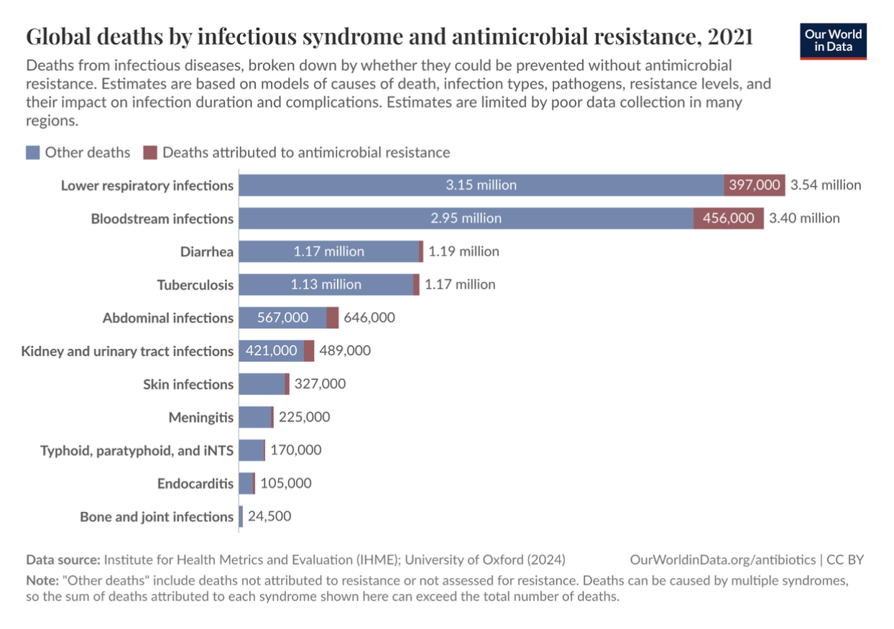
(Our World in Data, 2021) Figure 1

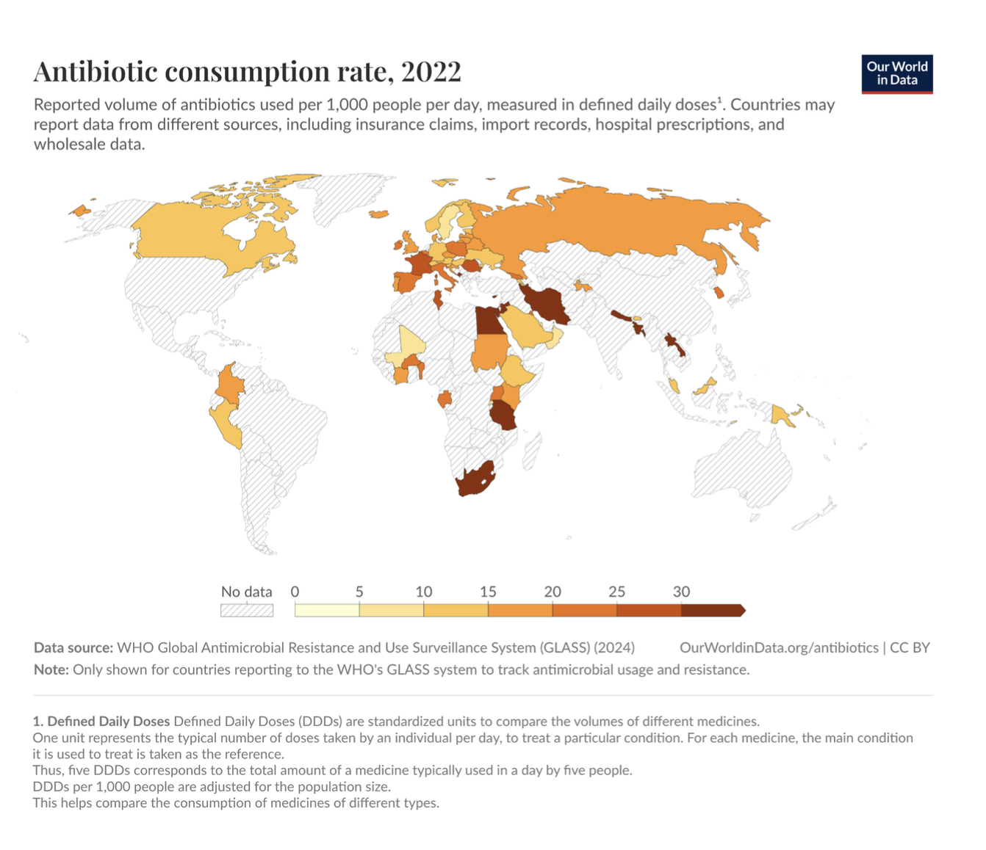
(Our World in Data, 2022) Figure 2
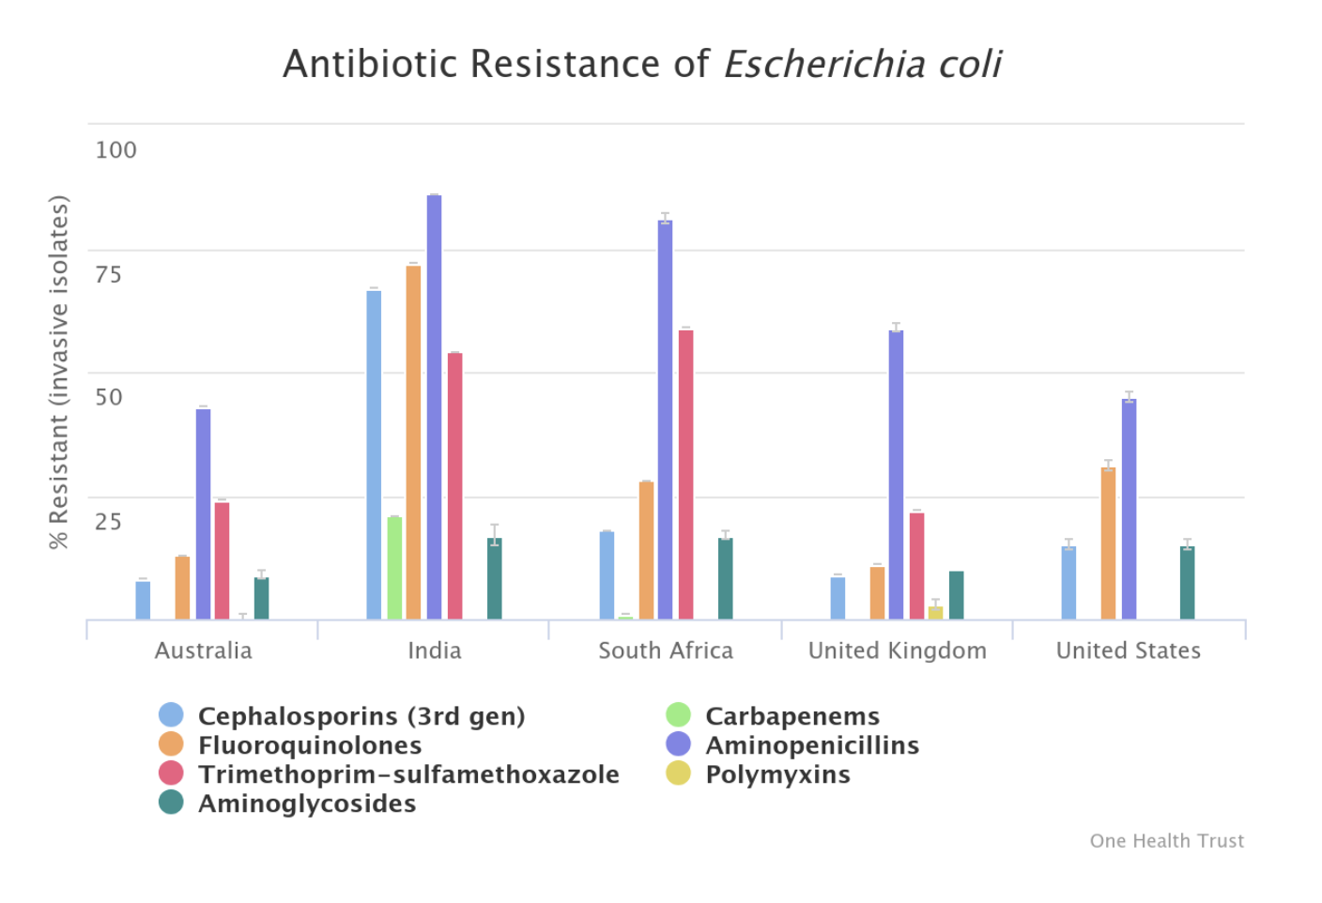
(OneHealth, 2019) Figure 3

Timeline

1928 | Alexander Fleming discovers penicillin
1940s | Penicillin is mass-produced during World War II
2015 | The World Health Assembly adopts the WHO Global Action Plan on Antimicrobial Resistance
2015 | WHO launches GLASS
2021-2025 | FAO implements its Action Plan on AMR
2022 | WHO publishes the AWaRe Antibiotic Book
2024 | WHO creates the Bacterial Priority Pathogens List
2024 | UN Member States adopt a new Political Declaration on AMR, to reduce global deaths associated with bacterial AMR by 10% by 2030

Major Parties

World Health Organization / Quadripartite – The main body responsible for controlling the global AMR response, mainly through the one health approach.
United States of America – Has a strong public-health agency and pharmaceutical research programs, allowing it to fund and execute projects through the CDC and through action plans.
India – Relevant due to its large population.
China – Similar to India, China contains a large population, and similar to the United States, China has a strong funding capacity.
Brazil – Contains large agricultural and livestock sectors, and therefore has increased levels of antibiotic use in animals and plants.
African States – Nigeria, South Africa, the Democratic Republic of the Congo, Uganda, Sierra Leone, and Liberia are all affected by AMR due to their weaker healthcare infrastructure.

Possible Solutions

The World Health Organisation at RCMUN 2026 should be in full cooperation to find solutions, working to ensure safe and controlled antimicrobial usage. The United Nations should work to ratify and reaffirm past agreements regarding the use of these antimicrobials, while ensuring that those who have developed antimicrobial resistance are treated adequately. With this, solutions should bear in mind the United Nations Sustainable Development Goals, and include these in proposed resolutions.

Committee Objective

The goal of the World Health Organization at RCMUN 2026 is to foster productive discussion about the growing issue of dealing with antimicrobial resistance. By noting major parties, possible outcomes and effects, and the impact of this issue, the committee hopes to
develop long-lasting solutions that all nations can benefit from and agree upon. Bearing in
mind all parties and their motives, the committee should strive for a fruitful debate, working
towards a common solution.

Sources

Centers for Disease Control and Prevention. “Antimicrobial Resistance Facts and Stats.”
CDC, February 4, 2025.
https://www.cdc.gov/antimicrobial-resistance/data-research/facts-stats/index.html.

Centers for Disease Control and Prevention. “2019 Antibiotic Resistance Threats Report.”
CDC, April 11, 2025.
https://www.cdc.gov/antimicrobial-resistance/data-research/threats/index.html.

European Commission. “A Global Commitment to Combat Antimicrobial Resistance
(AMR).” European Commission, October 1, 2024.
https://health.ec.europa.eu/latest-updates/unga-political-declaration-global-commitment-com
bat-antimicrobial-resistance-amr-2024-10-01_en.

Food and Agriculture Organization of the United Nations. The F AO Action Plan on
Antimicrobial Resistance 2021–2025. Rome: FAO, 2021.
https://www.fao.org/documents/card/en/c/cb5545en.

Murray, Christopher J. L., Kevin S. Ikuta, Fablina Sharara, Lucien Swetschinski, Gisela
Robles Aguilar, Authia Gray, Chieh Han, et al. “Global Burden of Bacterial Antimicrobial

Resistance in 2019: A Systematic Analysis.” The Lancet 399, no. 10325 (2022): 629–655.
https://www.thelancet.com/journals/lancet/article/PIIS0140-6736(21)02724-0/fulltext.

Organisation for Economic Co-operation and Development. Embracing a One Health
Framework to Fight Antimicrobial Resistance. Paris: OECD Publishing, 2023.
https://www.oecd.org/en/publications/embracing-a-one-health-framework-to-fight-antimicrob
Ial-resistance_ce44c755-en.html.

Our World in Data. “Antibiotic Consumption Rate.” Accessed June 17, 2026.
https://ourworldindata.org/grapher/antibiotic-consumption-rate.

Our World in Data. “Countries Enrolled in the WHO’s Program to Monitor Antimicrobial
Consumption and Resistance.” Accessed June 17, 2026.
https://ourworldindata.org/grapher/countries-enrolled-in-glass-surveillance-of-antimicrobial-c
onsumption-and-resistance.

Our World in Data. “National System to Monitor the Spread of Antimicrobial Resistance in
Humans.” Accessed June 17, 2026.
https://ourworldindata.org/grapher/national-system-to-monitor-spread-of-antimicrobial-resist
ance-in-humans.

United Nations General Assembly. Political Declaration of the High-Level Meeting on
Antimicrobial Resistance. New York: United Nations, 2024.
https://www.un.org/pga/wp-content/uploads/sites/108/2024/09/FINAL-Text-AMR-to-PGA.pd
f.

World Bank. Drug-Resistant Infections: A Threat to Our Economic Future. Washington, DC:
World Bank, 2017.
https://documents1.worldbank.org/curated/en/323311493396993758/pdf/final-report.pdf.

World Bank. “Antimicrobial Resistance.” World Bank, 2024.
https://www.worldbank.org/en/topic/health/brief/antimicrobial-resistance-amr.

World Health Organization. “Antimicrobial Resistance.” WHO, November 21, 2023.
https://www.who.int/news-room/fact-sheets/detail/antimicrobial-resistance.

World Health Organization. Global Action Plan on Antimicrobial Resistance. Geneva: World
Health Organization, 2015. https://www.who.int/publications/i/item/9789241509763.

World Health Organization. Global Antibiotic Resistance Surveillance Report 2025. Geneva:
World Health Organization, 2025. https://www.who.int/publications/i/item/9789240116337.

World Health Organization. WHO Bacterial Priority Pathogens List, 2024. Geneva: World
Health Organization, 2024. https://www.who.int/publications/i/item/9789240093461.

World Health Organization. WHO AWaRe Antibiotic Book. Geneva: World Health
Organization, 2022. https://www.who.int/publications/i/item/9789240062382.

World Organisation for Animal Health. “Antimicrobial Resistance.” WOAH. Accessed June
17, 2026. https://www.woah.org/en/what-we-do/global-initiatives/an

